Name_________________________________ Period _____________ Date ________________



**Lesson 4: The Optimal Dronopter**

You’ve investigated how the frame type, motor type, and motor position affects the stable flight of a dronopter. Now it’s time to put those results to use in creating a dronopter that flies a course in the *least* amount of time. Suit up and fly right.

**Doing the Science**

1. Start the Dronopter Simulation by clicking on the “Sim” tab.

2. Select and drag the best frame to the center of the table. Record the frame type in Table 1.

3. Select and drag to each corner of the frame the ideal motor for your dronopter. Use Figure 1 to record in Table 1 the motor type and positioning.

4. Click the “Test” button to test fly your dronopter.

5. On the next screen, drag the red circular joystick handle to control the thrust and fly the complete course. You must touch each target’s bullseye with the arrow on your dronopter as you fly the course. The target will turn green when successfully hit.

6. If you successfully fly the entire course, record your time of flight in Table 1 Flight Results.

7. If you *cannot* fly the entire course but do hit some targets, record your number of targets successfully hit in Table 1 Flight Results.

8. If needed, select the “Build” button to return to the first screen to redesign your dronopter.

Figure 1.

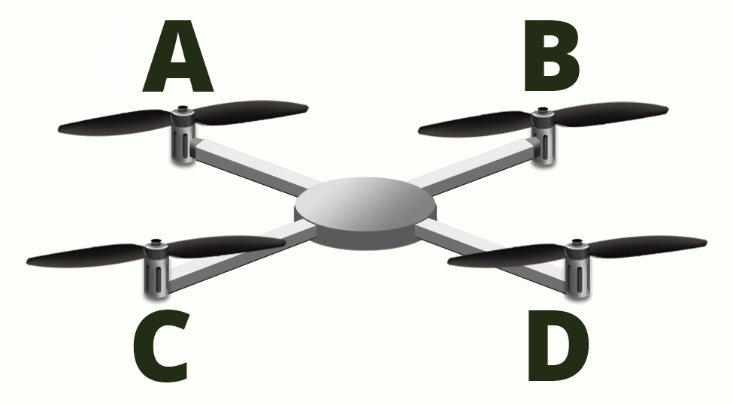

Table 1.

|  |  |  |  |  |  |
| --- | --- | --- | --- | --- | --- |
| **Frame type** | **Position A**  **Motor** | **Position B**  **Motor** | **Position C**  **Motor** | **Position D**  **Motor** | **Flight Results** |
|  |  |  |  |  |  |
|  |  |  |  |  |  |
|  |  |  |  |  |  |

**Do You Understand?**

1. Which frame type, motor type, and position resulted in the fastest flight of the entire course?

2. If you had unlimited frame materials and motor types, how would you redesign your dronopter to have the fastest and most stable flight?